Our Quality Promise

We have a commitment to ensure that our service will:

- Treat the people we support with the dignity and respect they deserve
- Understand that people we support have individual needs and preferences and work with them to make sure they have a say in how their support is provided
- Understand that peoples’ needs change and be flexible in how we provide services to make sure needs are always met
- Support people to make choices and decisions about their service and their lives
- Work with people we support to help them to achieve what is important to them
- Provide support which is honest, trustworthy and open
- Provide staff who have the training, qualifications and experience necessary to provide personalised support
- Provide support which is safe both for the people we support and for our staff
- Act quickly to put things right if there is a problem

Who We Are and What We Do

Mediline Supported Living Ltd. is a care and training provider offering a wide range of services. Since 1986 we have supported people to live independently in their own homes and in their community. Through our training branch, we have helped many people gain qualifications. Our head office is in Merseyside and we have offices in Manchester and Standish. In 2016 North West Community Services joined the Mediline Group which means we will be able to offer services over a larger area.

We are a ‘provider of choice’ for many people because our services are high quality and personalised. This means we work closely with you to make sure that our services meet your needs in the way that you want. We think it is very important to put you first to help you to live your life the way you want to.
Leadership

All of our Directors and Managers are committed to making sure the services we provide are of a high quality and are person centred.

The Managing Director and the Quality Manager make sure that our Quality Policy is followed in everything we do. All services are regularly reviewed and checked to make sure they are meeting the standards we expect.

People Matter
The most important part of our service is YOU – the people we support and the staff who provide support. Your voice – your ideas – and your suggestions are important to us to help us to always keep getting better so that we can provide the best service possible.

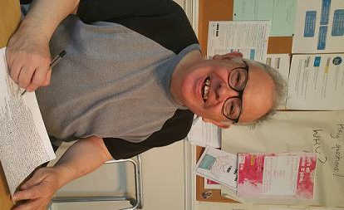
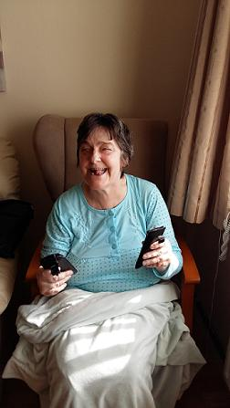
Continual Improvement

Every year Mediline Supported Living makes a Business Plan which sets out our goals and how we will get there. An important part of the Business Plan is how we can or should make our services better. We decide this by listening to what you, our staff and other agencies have to say about our services.

Managing Diretor,Mediline Supported Living Ltd. November 2021

Making Sure People Know About Our Policy
We display our Quality Policy Statement on all notice boards in local offices. We also let everyone we work with know about our Quality Policy Statement.

